Student worksheet

8.1 There are different ways of reproducing

Pages 140–141 and 211

Reproduction

1 What is the difference between sexual and asexual reproduction?

Asexual reproduction

2 What can be said of the genetic material between parent and offspring in asexual reproduction?

3 What is binary fission?

4 What is parthenogenesis?

5 Give an example of an organism that undergoes parthenogenesis.

6 What is fragmentation?

7 Give an example of an organism that undergoes fragmentation.

8 What is fragmentation in plants called?

9 What parts of a plant does the term in question 8 refer to? Give three examples.

Sexual reproduction

10 What is sexual reproduction?

11 What is offspring?

12 Why is variation within a population important?

13 What is the difference between identical and non-identical twins in terms of their DNA?

Hermaphrodites

14 What is a hermaphrodite?

15 Some organisms that are hermaphrodites can ‘turn off’ one sexual system. When and why would this be beneficial?

Extend your understanding

Hermaphroditism sometimes occurs in humans.

16 What tissues and organs must a human be born with in order to be a hermaphrodite?

17 What happens in the fertilisation process for hermaphroditism to occur in humans?

18 What is the more common and accepted term for a person who is a hermaphrodite?

Student worksheet

8.2 The female reproductive system produces eggs in the ovaries

Pages 142–143

Female reproduction

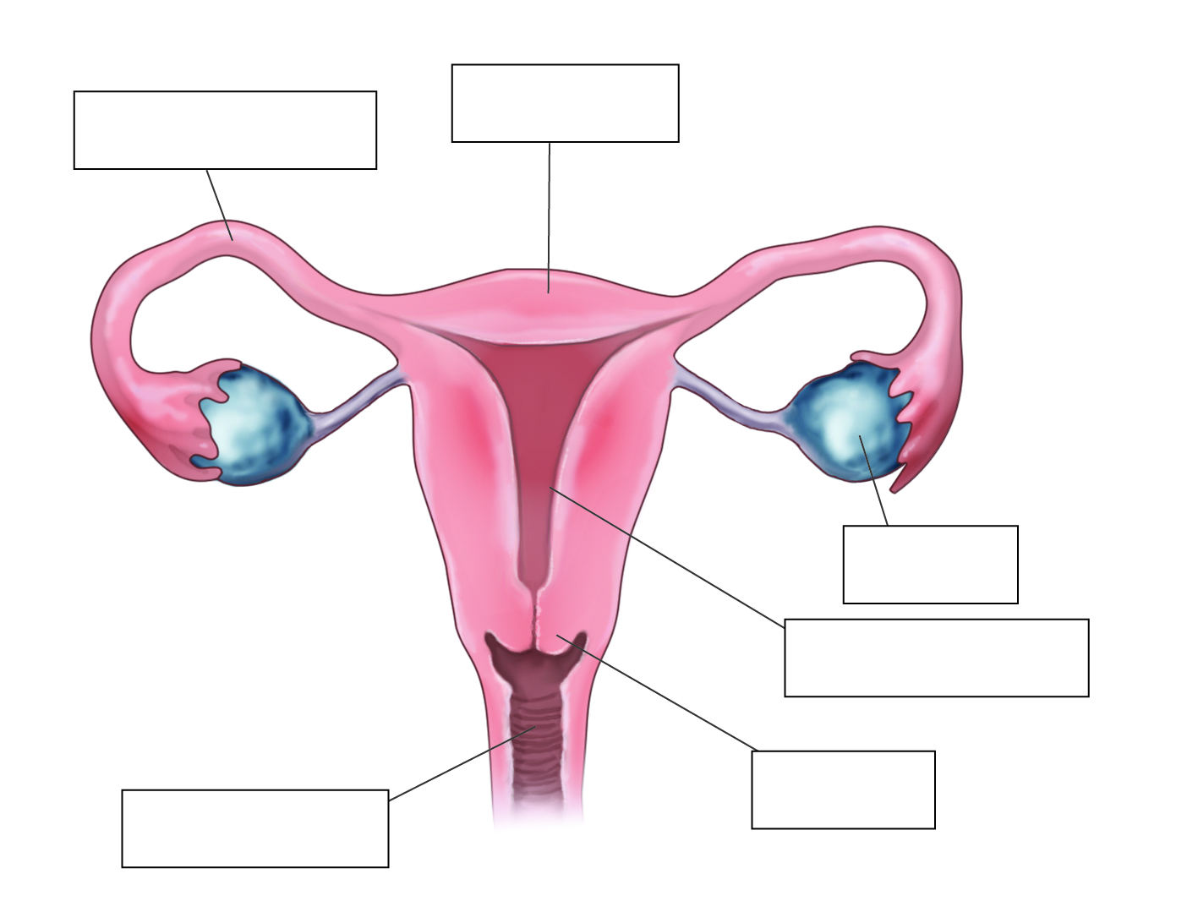1 Label the following diagram of the human female reproductive system.

2 Match the organ involved in the female reproductive system to its function.

|  |  |  |
| --- | --- | --- |
| ORGAN |  | FUNCTION |
| 1 Cervix |  | A Female reproductive cell |
| 2 Vagina |  | B Contain egg cells |
| 3 Ovaries |  | C Tissue at the entrance to the uterus that keeps a foetus in place while a woman is pregnant |
| 4 Uterus |  | D Carry the egg into the uterus |
| 5 Fallopian tubes |  | E Where a foetus develops until it is born |
| 6 Egg |  | F Canal between the cervix and the vulva |
| 7 Endometrium |  | G Lining of the uterus |

3 What is ovulation?

4 Explain the function of oestrogen. What is the name for this type of chemical?

5 What is the name of the organ that nourishes the baby?

6 What is a gestation period?

7 What is the average age that females first get their period?

8 On average, how long do menstrual periods last?

9 Explain the three stages of childbirth.

Extend your understanding

Some women take an oral contraceptive (‘the pill’) to help regulate their mentrual cycle, avoid period pain and prevent pregnancy. The pill contains synthetic versions of oestrogen and progesterone, which females make naturally. The oestrogen stops the ovum from releasing the egg and the progesterone thickens the fluid at the opening of the cervix and stops sperm from getting through. Research oral contraceptives and answer the following questions.

10 Is it possible to become pregnant when having sex for the first time?

11 Explain how it may be possible for a female to become pregnant when they are taking an oral contraceptive.

12 An oral contraceptive can be manufactured using only one of the hormones mentioned above. What is the benefit of using both hormones instead of just one?

13 List other forms of contraception that either males or females can use to prevent pregnancy.

Student worksheet

8.3 The male reproductive system produces sperm in the testes

Pages 144–145

Male reproduction

1 What is the difference between internal and external fertilisation?

2 Explain what happens during fertilisation, mentioning all cells involved.

3 Where is sperm produced?

4 Explain the function of testosterone. What is the name for this type of chemical?

5 Why is the scrotum outside of the body?

6 Label the following diagram of the male reproductive system.

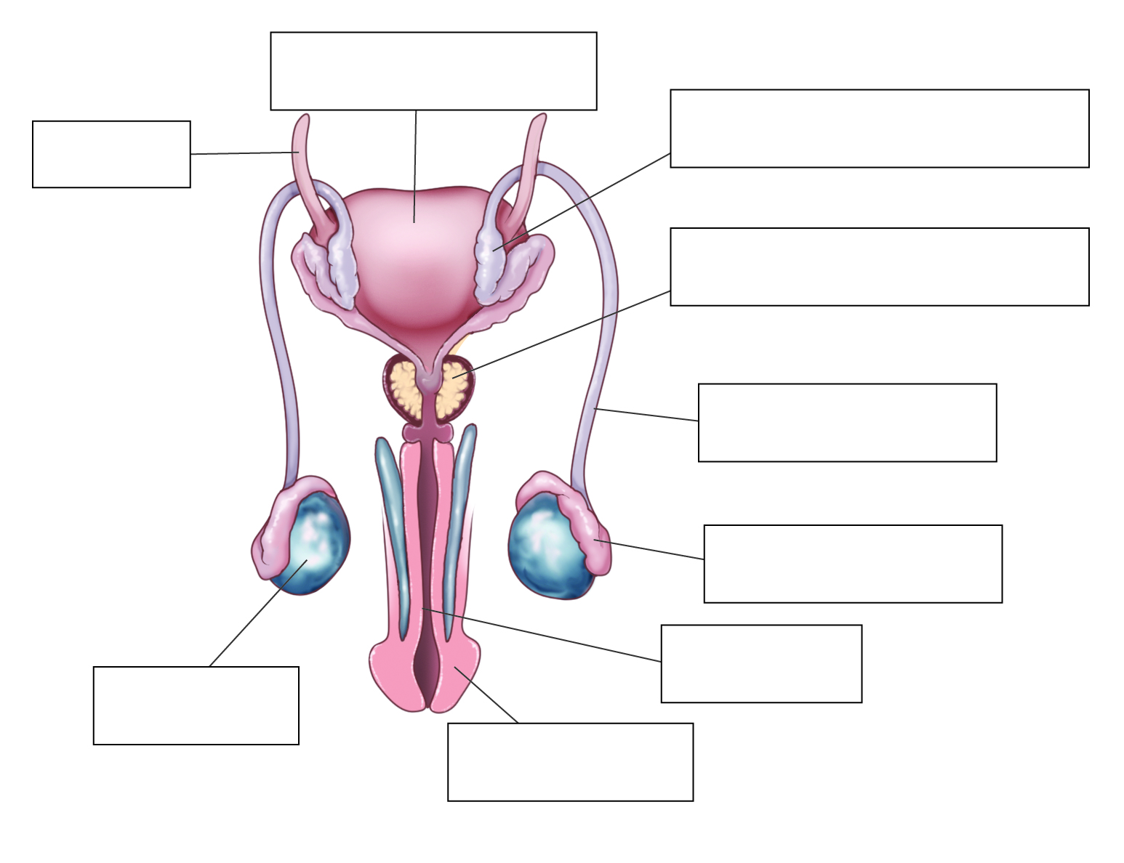

7 Match the organ involved in the male reproductive system to its function.

|  |  |  |
| --- | --- | --- |
| ORGAN |  | FUNCTION |
| 1 Vas deferens |  | A An organ that swells with blood and stiffens during an erection |
| 2 Testes |  | B Male reproductive cell |
| 3 Penis |  | C A walnut-sized structure that blocks the flow of urine so that the sperm can be ejaculated out through the penis |
| 4 Prostate gland |  | D Transports sperm from the testes to become semen |
| 5 Urethra |  | E Produce sperm cells and the male sex hormones |
| 6 Sperm |  | F Carries semen or urine out of the body |
| 7 Seminal vesicles |  | G Where sperm mature |
| 8 Epididymis |  | H Small pouch-like structures that provide a fluid that is needed for the sperms’ journey |

8 There are two monotremes in the world and both are located in Australia. What are these two animals?

9 What do birds, reptiles and monotremes have in common in their ability to reproduce?

10 In comparison to humans, name three differences in the way that amphibians and fish reproduce.

Extend your understanding

11 Complete the table below to compare human male and female reproduction (pages 140–145 of your student book).

|  |  |  |
| --- | --- | --- |
| Characteristic | Male | Female |
| Gamete |  |  |
| Main hormone |  |  |
| Organ that produces gamete |  |  |
| Tubes that provide a pathway for the gamete |  |  |
| External genitalia (yes or no) |  |  |

Student worksheet

8.4 Things sometimes go wrong in reproduction

Pages 146–147 and 211

Problems in the reproductive system

Endometriosis

1 Which reproductive organ does endometriosis involve?

2 What is the cause of endometriosis?

3 What are the effects of endometriosis?

Human reproduction

4 What is ART?

5 What is IVF? Explain the process.

6 What are the benefits of ART?

7 What are the potential risks involved with screening tests?

Preserving biodiversity

8 Why is it important to stop species from becoming extinct?

9 What is a captive breeding program?

10 What are the advantages of captive breeding programs?

Contraception and desexing

11 What does contraception do?

12 What are the benefits of contraception in captivity?

13 What is desexing? How is it performed?

14 What are the benefits of desexing animals?

Extend your understanding

15 Choose one of the three reproductive problems below and answer the following questions.

*Fibroids Epididymitis Erectile dysfunction*

a In which reproductive organ does the condition occur?

b What is the cause of this condition?

c What effects can this condition have on your body?

d What is the treatment?

e Is there any way to manage the condition to avoid it happening again or limit ongoing effects?

Student worksheet

8.5 Plant sexual reproduction produced seeds

Pages 148–149 and 212

Plant sexual reproductive system

1 Label the reproductive organs of a flower on the diagram below.

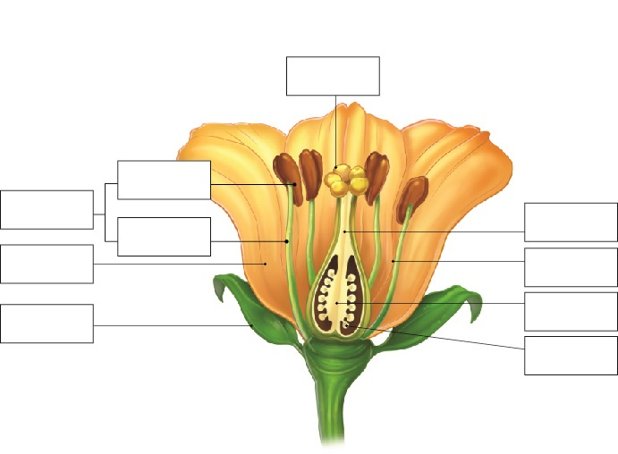

2 Match the organ in the reproductive system of a plant with its function.

|  |  |  |
| --- | --- | --- |
| ORGAN |  | FUNCTION |
| 1 Stigma |  | A Name for the female egg |
| 2 Pollen |  | B Organ located at the top of the male structure |
| 3 Carpel |  | C Organ where the female egg is produced |
| 4 Ovary |  | D The ovum is located at the base of this organ |
| 5 Anther |  | E Path that the pollen must follow to reach the ovary |
| 6 Ovum |  | F Name of the male gamete |
| 7 Pollen tube |  | G Name of the three female parts together |

3 Label the structure of the carpel below.

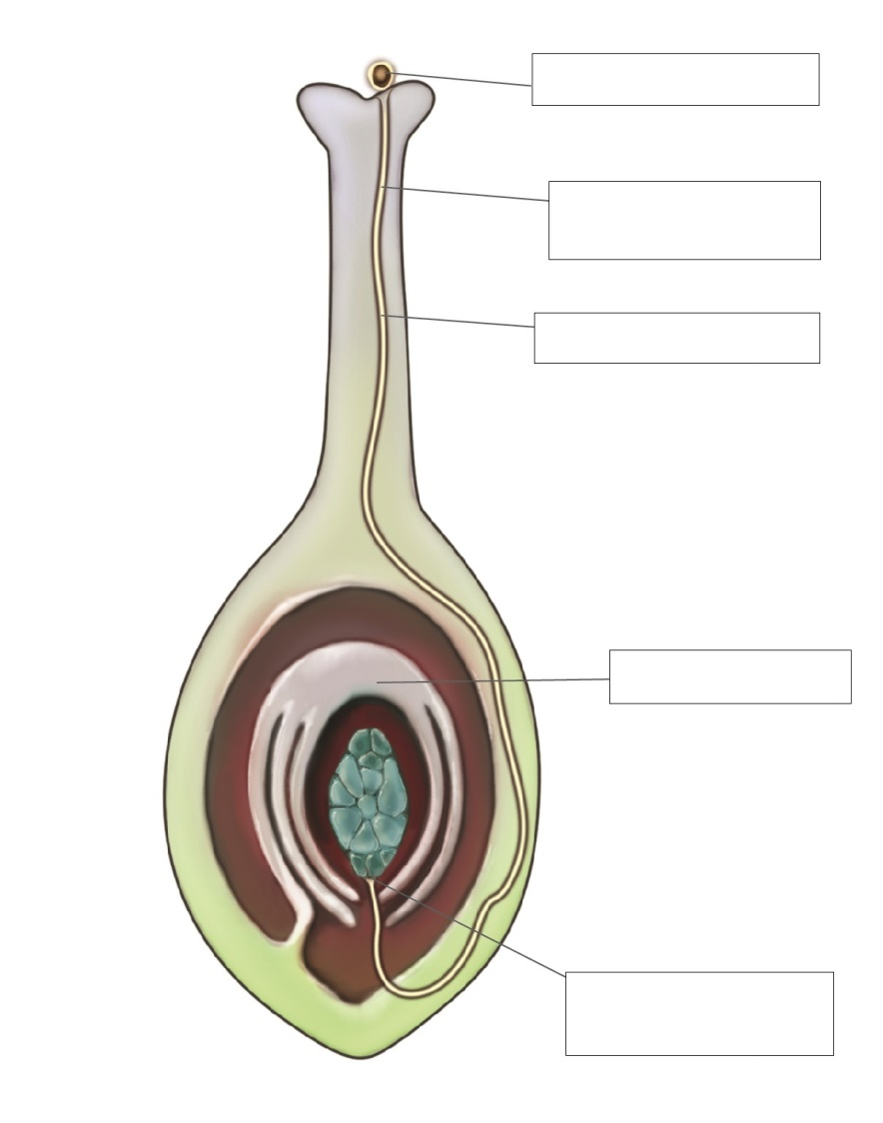

4 Name the three types of pollination and explain how each occurs.

5 What are the benefits of a flower being colourful and having a strong smell?

6 What are spores?

7 How do ferns reproduce?

Extend your understanding

8 For each of the plants below, use what you have learnt to explain how each plant reproduces and how they attract animals to aid them in reproducing.

|  |  |
| --- | --- |
| D:\OS8 worksheets and aw\jpgs ready for worksheets\SW0809_00951-r.jpg  Rafflesia | How does it reproduce?      How does it attract animals? |
| D:\OS8 worksheets and aw\jpgs ready for worksheets\SW0810_00951-r.jpg  Bottlebrush | How does it reproduce?      How does it attract animals? |
| D:\OS8 worksheets and aw\jpgs ready for worksheets\SW0811_00951-r.jpg  Daffodil | How does it reproduce?      How does it attract animals? |

Student worksheet

8.6 Reproduction techniques have an impact in agriculture

Pages 150–151

Selective breeding and its impacts

1 What is selective breeding?

2 Why have sperm banks for animals been set up?

3 How does selective breeding occur in plants?

4 Give an example of one plant and two animals that are typically bred as a result of selective breeding.

5 How can selective breeding lead to a loss of diversity in a population?

6 How does selective breeding put a population at risk of disease? Give an example.

7 What happened to potatoes in the mid-1800s as a result of lack of diversity?

8 What was the consequence of this potato event on the human population?

9 What is inbreeding?

10 What is the result of inbreeding within a population?

Extend your understanding

11 Inbreeding can cause numerous physical and behavioural problems in many animals. Research any three animals and explain some physical and behavioural issues that they face due to inbreeding.